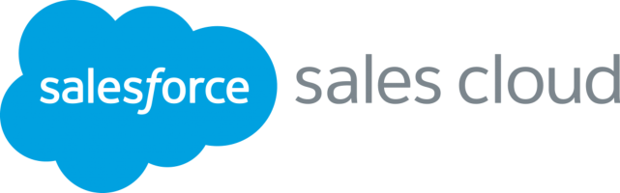

|  |
| --- |
| **SalesForce Sales Cloud Training Curriculum** |

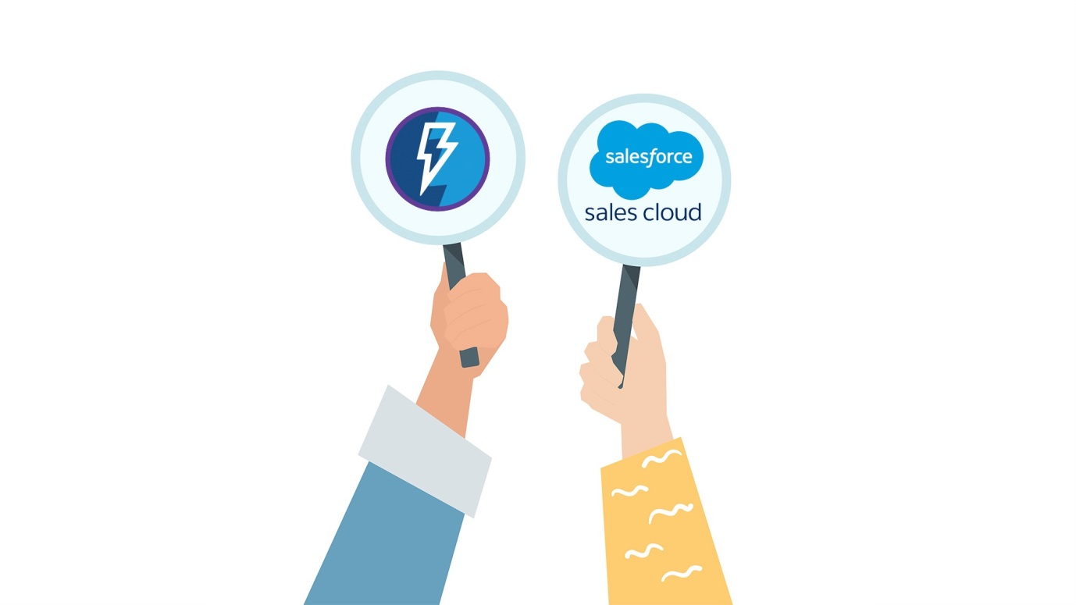

|  |
| --- |
| **SalesForce Sales Cloud Consultant Training** |

|  |
| --- |
| **(Salesforce Certified Sales Cloud Consultant)**   * A **Salesforce Certified Sales Cloud Consultant** designs and deploys solutions that support customer business processes and requirements using Salesforce applications. The consultant has experience designing solutions that optimize the Sales Cloud functionality and can lead the implementation of these solutions within a customer organization. The consultant has experience working with sales and marketing organizations and has expertise in Salesforce applications, including the knowledge needed to implement multiple applications in common customer scenarios. * **What You will Learn :**    + Understand the entire core concepts found on the Salesforce Sales Cloud Certification Exam.   + Configure Salesforce Lightning Pages.   + Create Multiple Salesforce Sales Processes.   + Extensive Opportunity Record Types, Stage Customizations and More. |

|  |  |
| --- | --- |
|  | **SalesForce Sales Cloud Consultant** |

1. **Introduction and Getting Started**

* Signing Up for a Free Salesforce Account - Keep it For Life
* Logging in to Salesforce and Switching Between Lightning and Classic

1. **Industry Knowledge**

* Industry Knowledge Introduction
* Sales Metrics and Factors that Influence Them
* KPIs and Business Challenges
* Common Sales Processes and Key Considerations

1. **Implementation Strategies**

* Implementation Strategies Introduction
* Scenarios and Successful Consulting Engagement Phases
* Planning Phase of Consulting Engagements
* Requirements Gathering Phase of Consulting Engagements
* Designing Phase of Consulting Engagements
* Building Phase of Consulting Engagements
* Testing Phase of Consulting Engagements
* Documentation Phase of Consulting Engagements
* Sales Deployment Considerations
* Measuring the Success of a Sales Cloud Implementation Project

1. **Sales Cloud Solution Design**

* Sales Cloud Solution Design Introduction
* Designing an End-to-End Sales Process
* It All Begins with a Lead in the Sales Process
* Lead Processes and Lead Qualification Stages
* Lead Field Mapping
* The Lead Conversion Process - an Opportunity is Born (and Contact and Account)
* Analysing Customer Requirements to Determine Appropriate Solution Design
* Implementing Quotes
* Validation Rules and the Sales Process
* Automation Tools and the Sales Process
* Configure, Price, Quote
* Account Teams
* Opportunity Teams
* Enterprise Territory Management Capabilities and Use Cases
* Implementing Orders in Salesforce
* Sales Process Capabilities of Salesforce Mobile
* Sales Process Use Cases of Salesforce Mobile
* Sales Process Design Considerations of Salesforce Mobile

1. **Marketing and Leads**

* Marketing and Leads Introduction
* Marketing Capabilities in the Sales Process
* Lead Scoring and Lead Qualification
* Managing Lead Data Quality

1. **Account and Contact Management**

* Account and Contact Management Introduction
* Activating Social Accounts and Contacts
* Account and Contact Ownership and Visibility Considerations
* Sharing Rules
* Associating a Contact to Multiple Accounts, Contact Roles, and Duplicate Rules
* Implementing Account Hierarchy and Its Impact
* Data.com for Data Enrichment
* Implementing Person Accounts

1. **Opportunity Management**

* Opportunity Management Introduction
* Implementing Multiple Sales Processes
* Sales Stages, Forecasts and Pipeline
* Introducing Assets
* Price Books and Opportunities
* Opportunity Product Line Items
* Product Scheduling and Opportunities
* Quotes and Opportunities
* Contracts
* Campaigns and Opportunities
* Setting Up Campaign Influence and Adding Influential Campaigns to Opportunities
* Collaborative Forecasting
* Multiple-Currency Impact on Opportunities

1. **Sales Productivity**

* Sales Productivity Introduction
* Enabling and Measuring Sales Productivity and Adoption
* Email Tools for Salesforce
* Enabling and Setting Up a Path on Opportunities
* Collaborating in the Sales Process Using Chatter
* Salesforce CRM Content and Chatter Files in the Sales Process
* Work.com and Sales Productivity
* Einstein in Sales Cloud
* Mobile Solutions for Sales Productivity

1. **Communities and Site Management**

* Communities and Site Management Introduction
* Implementing Communities
* Implementing Ideas for Page Layout
* Force.com Sites

1. **Sales Cloud Analytics**

* Sales Cloud Analytics Introduction
* Sales Reports
* Report Filters, Sharing Rules, Teams and Visibility
* Sales Dashboards
* Sales Reporting Snapshots

1. **Integration and Data Management**

* Integration and Data Management Introduction
* Common Sales Cloud Integrations
* Sales Cloud Data Migration & Enabling Deferred Sharing
* Large Data and Transaction Volumes